**OUTPUT of Operations on table:**

**Output of Performing operations on table:**

**(On Python Idle)**

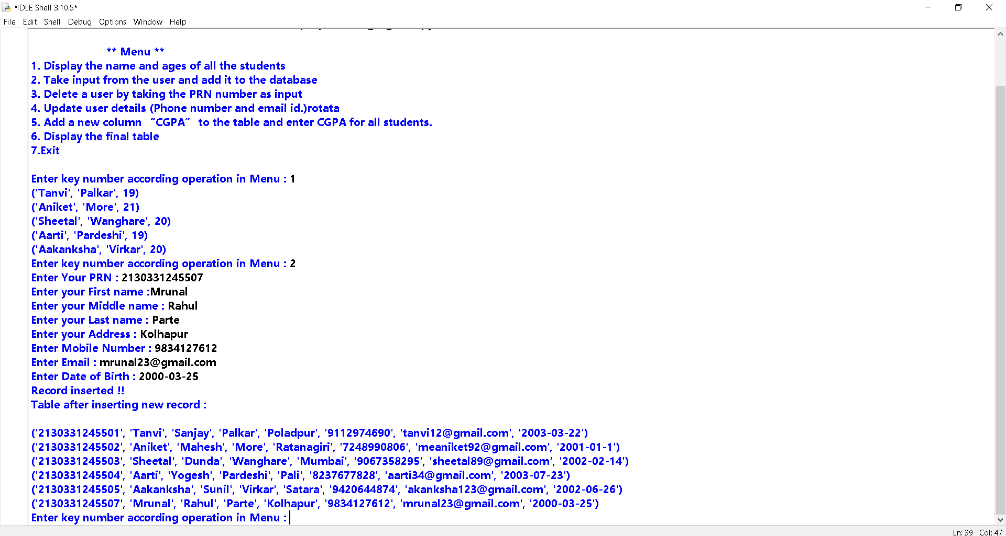

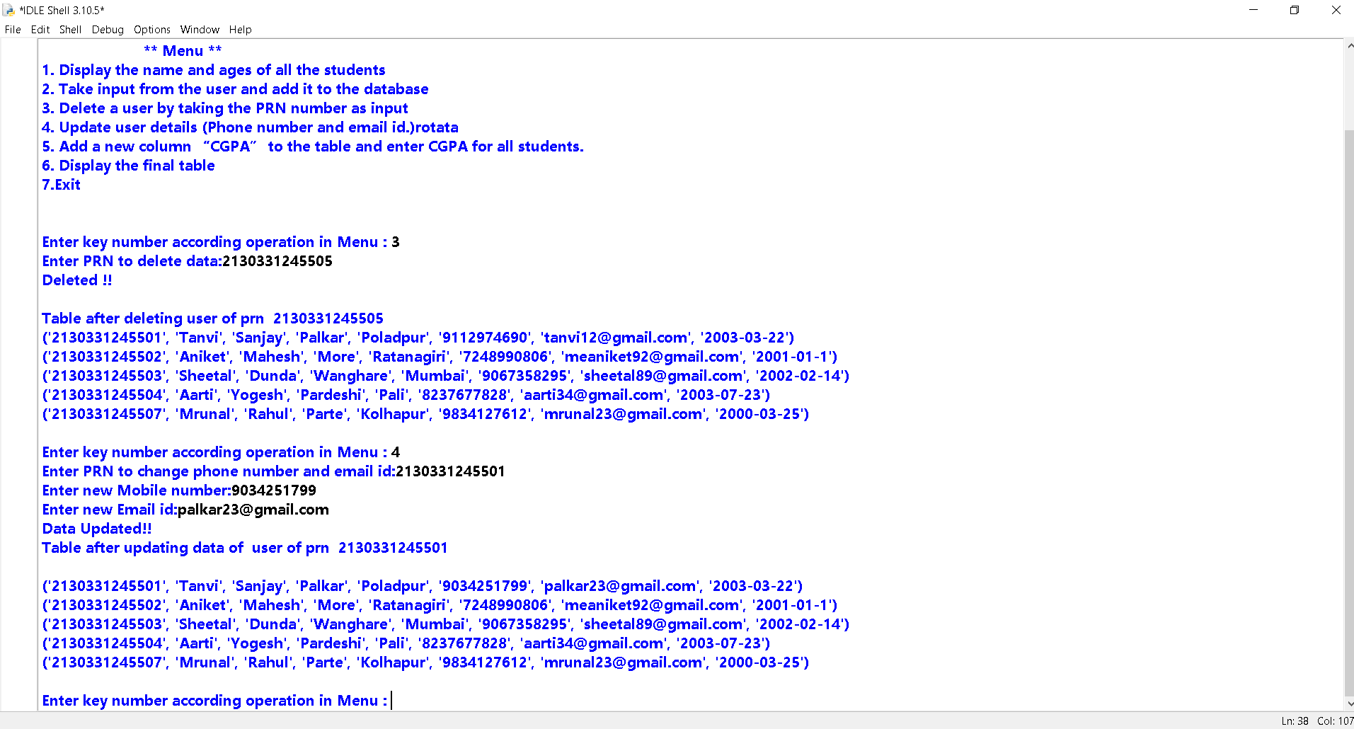

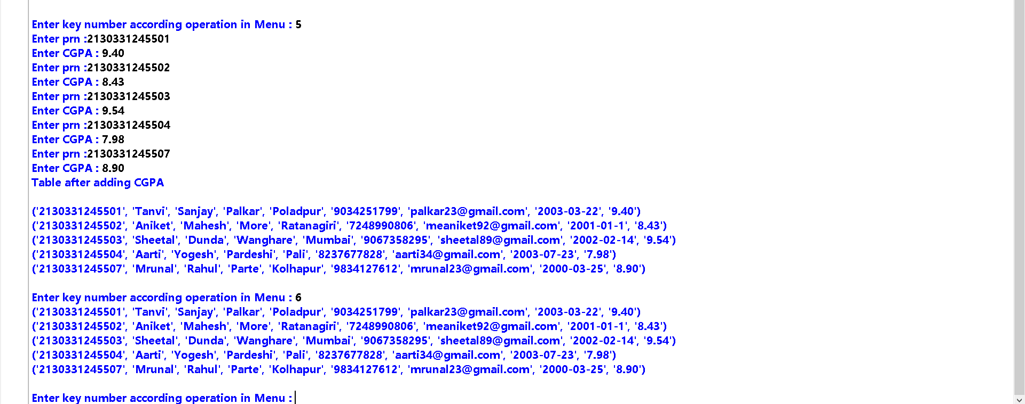

**Output on Sql console:**

1. **Display the name and ages of all the students**

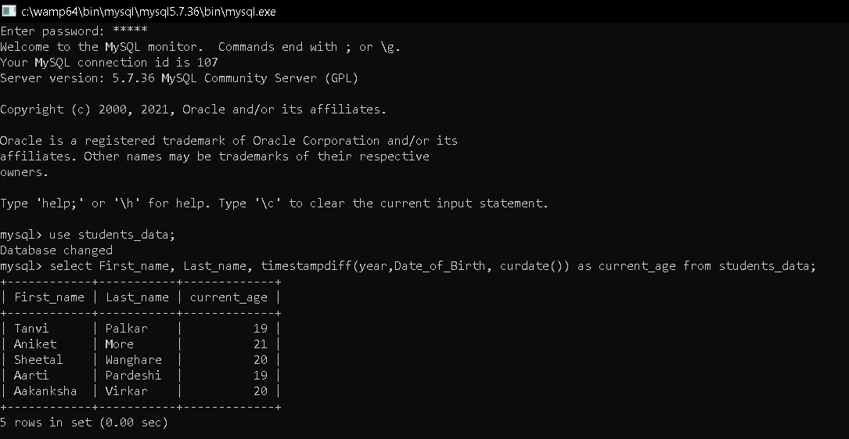

1. **After taking input from user and adding it to table:**

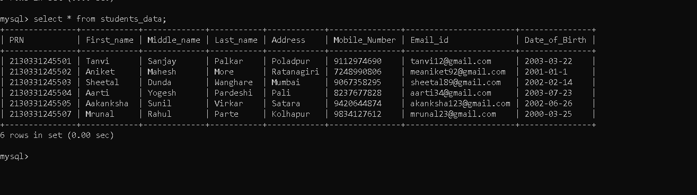

1. **After deleting record by taking input as PRN from user:**

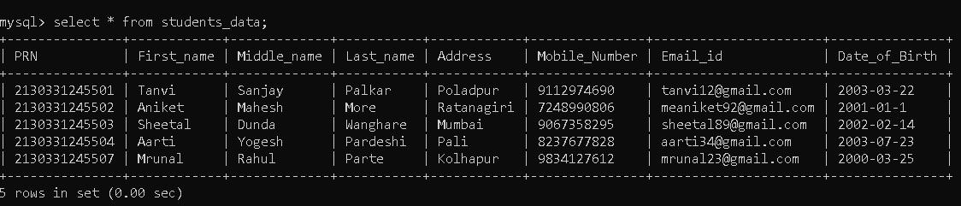

1. **After updating mobile and email id for given PRN :**

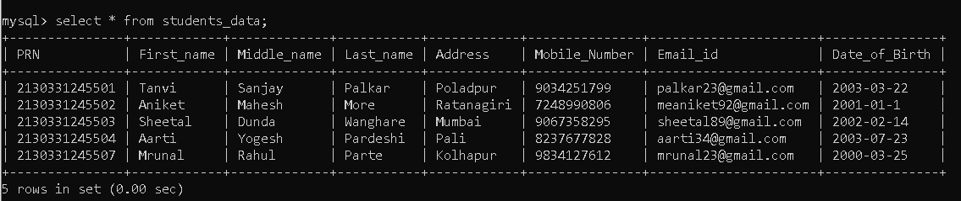

1. **Adding new column CGPA and inserting value for each record:**

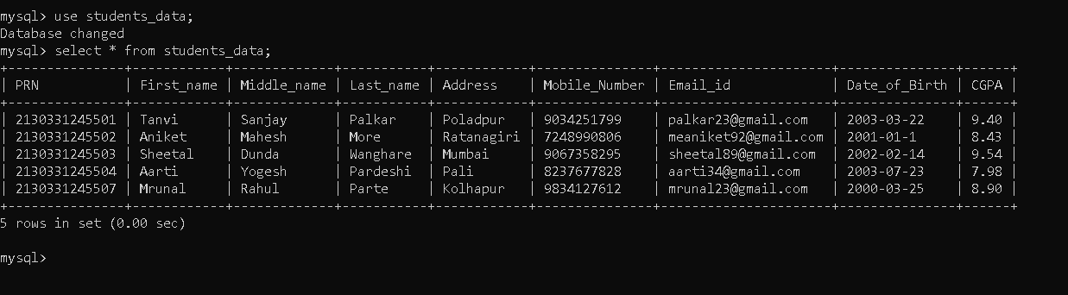

1. **Displaying Final table:**

